Task 1: Student Registration & Data Storage
AIM: To design a Student Registration Form using HTML5 and CSS3, collect user details (Name, Email, DOB, Department, Phone), store the data in a database, and retrieve it using an SQL SELECT query.
ALGORITHM:
Step 1: Start
Step 2: Open the web page in browser
Step 3: Display the Student Registration Form
Step 4: Enter Name in the input field
Step 5: Enter Email ID
Step 6: Select Date of Birth
Step 7: Choose Department from dropdown
Step 8: Enter Phone Number
Step 9: Click on Submit button
Step 10: Check whether all fields are filled
Step 11: Validate Email format
Step 12: Validate Phone number format
Step 13: If validation fails, display error message
Step 14: If validation is correct, send data to server
Step 15: Establish connection with database
Step 16: Check database connection status
Step 17: Insert student data into table
Step 18: Check whether data is inserted successfully
Step 19: Display “Registration Successful” message
Step 20: Execute SELECT query to retrieve data
Step 21: Fetch all records from database
Step 22: Display student details on screen
Step 23: Close database connection
Step 24: Stop

CODES:
HTML:
<!DOCTYPE html>
<html>
<head>
<title>Student Registration</title>
<style>
body {
font-family: Arial;
background-color: #f2f2f2;
}
.form-container {
width: 400px;
margin: auto;
padding: 20px;
background: white;
border-radius: 10px;
}
input, select {
width: 100%;
padding: 10px;
margin: 8px 0;
}
button {
width: 100%;
padding: 10px;
background: blue;
color: white;
border: none;
}
</style>
</head>
<body>

<div class="form-container">
<h2>Student Registration</h2>
<form action="register.php" method="post">
<input type="text" name="name" placeholder="Name" required>
<input type="email" name="email" placeholder="Email" required>
<input type="date" name="dob" required>

<select name="department" required>
<option value="">Select Department</option>
<option>CSE</option>
<option>ECE</option>
<option>EEE</option>
<option>MECH</option>
</select>

<input type="text" name="phone" placeholder="Phone" required>
<button type="submit">Register</button>
</form>
</div>

</body>
</html>

DATABASE(MYSQL):
CREATE DATABASE student_db;

USE student_db;

CREATE TABLE students (
id INT AUTO_INCREMENT PRIMARY KEY,
name VARCHAR(50),
email VARCHAR(50),
dob DATE,
department VARCHAR(20),
phone VARCHAR(15)
);

PHP:
<?php
$conn = new mysqli("localhost", "root", "", "student_db");

if ($conn->connect_error) {
die("Connection failed: " . $conn->connect_error);
}

if ($_SERVER["REQUEST_METHOD"] == "POST") {
$name = $_POST['name'];
$email = $_POST['email'];
$dob = $_POST['dob'];
$department = $_POST['department'];
$phone = $_POST['phone'];

$sql = "INSERT INTO students (name, email, dob, department, phone)
VALUES ('$name', '$email', '$dob', '$department', '$phone')";

if ($conn->query($sql) === TRUE) {
echo "Registration Successful<br><br>";
} else {
echo "Error: " . $conn->error;
}
}

$result = $conn->query("SELECT * FROM students");

echo "<h3>Registered Students</h3>";

while ($row = $result->fetch_assoc()) {
echo $row['name'] . " | " .
$row['email'] . " | " .
$row['dob'] . " | " .
$row['department'] . " | " .
$row['phone'] . "<br>";
}

$conn->close();
?>

OUTPUT:
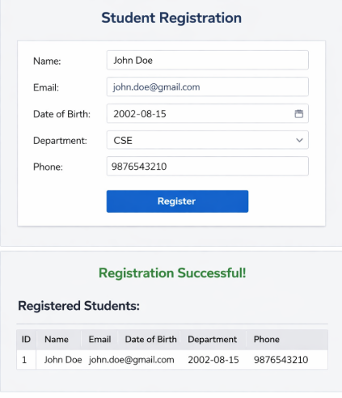

RESULT:
The Student Registration Form was successfully designed using HTML5 and CSS3. The entered data was stored in the MySQL database and retrieved using an SQL SELECT query. The application worked correctly by displaying stored student details dynamically.

